RESUME 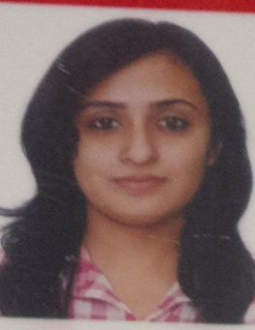

**Name:** Veena Ashok Verekar

**Address**: C/O Ashok Verekar, H.No. 325, Madhala Wada, Savoi-Vere, Ponda, Goa.

**Contact No**: Mobile Number -7507887213,

Landline Number-08322340741.

**Email address**: [veenavav@gmail.com](mailto:veenavav@gmail.com).

**Birth date:** 08/01/1989

**Qualification:**

|  |  |  |  |
| --- | --- | --- | --- |
| Degree | Board | Passing Year | Class |
| S.S.C. | GOA | March 2004 | First |
| H.S.S.C. | GOA | March 2006 | Second |
| B.Sc | GOA UNIVERSITY | April 2010 | First |
| M.A | DECCAN UNIVERSITY | April 2013 | First |

**Additional Qualification:-**

|  |  |
| --- | --- |
| Diploma In GIS | A Grade |
| Diploma In Typewriting | **40 WPM** |
| Diploma In Computer application | **A Grade** |

**Languages Known**: English, Hindi, Marathi and Konkani.

**Work Experience**:

Supertech Solution Ltd April 2013- April 2014

Joined as a marketing co-ordinator.

Key role:

* Track product line sales and costs by analyzing and entering sales, expense, and new business data.
* Prepare marketing reports by collecting, analyzing, and summarizing sales data.
* Support sales staff by providing sales data, market trends, forecasts, account analyses, new product information; relaying customer services requests.
* Plan meetings and trade shows by identifying, assembling, and coordinating requirements; establishing contacts; developing schedules and assignments; coordinating mailing lists.

Samruddha Jeevan Multi-State Multi-Purpose Co-Operative Society Pvt-Ltd. May 2014- present.

Joined as Agency Manager

Key Role:

* Acquisition of Fixed Deposit
* To sell different Financial product like Fixed deposit, Recurring Deposit, Loan.
* Generate leads of customer through referral, meeting branch walk-ins customer, associates, e-mailing
* Recruiting sales officer to sale financial product.
* Reporting to Branch Manager.

DISTRICT : NORTH GOA  
CITY : PONDA  
BRANCH NAME : PONDA